Other Forms
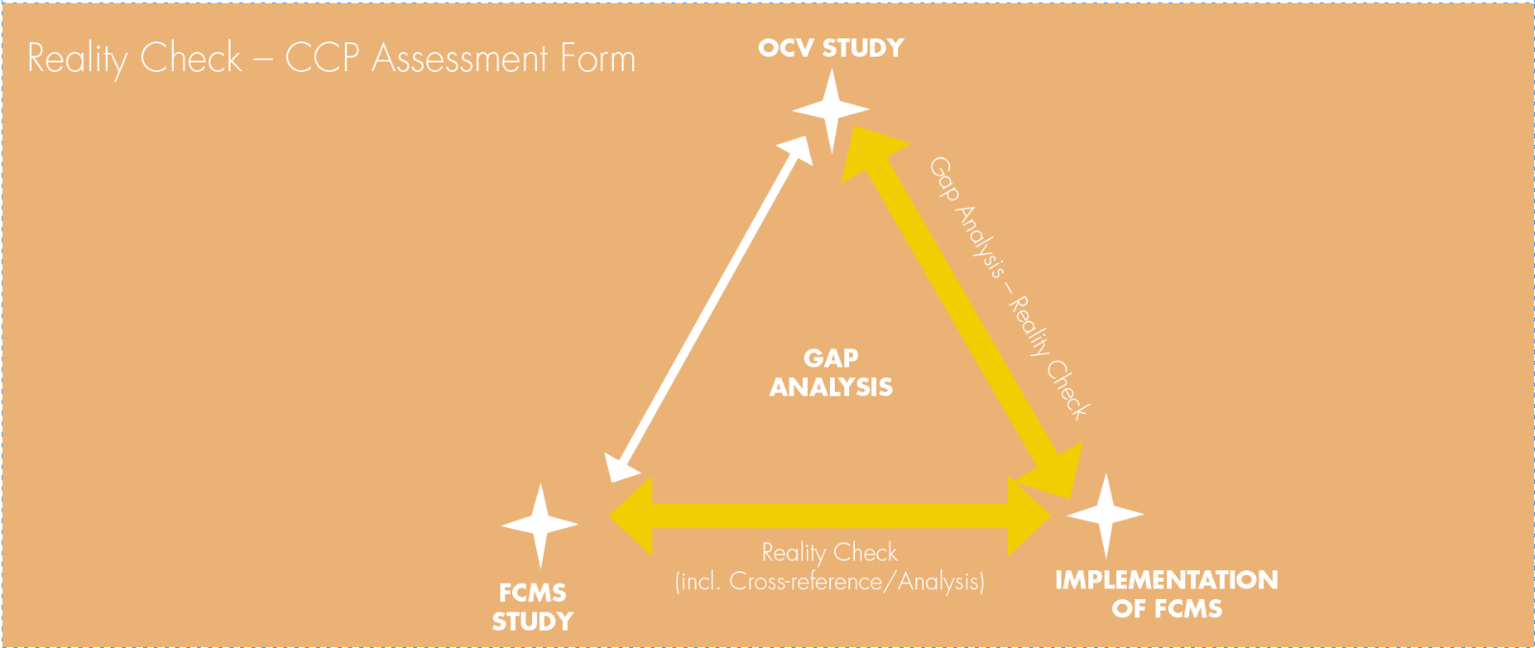

Business Name:
Officer:
Date of Reality Check:
Product:
CCP:
Record Sources of Evidence
Has the CCP been correctly identified?
Critical Limits
(Appropriate, achieved in practice)
Monitoring
(Appropriate frequency, trained staff, consistent with written procedure)
Corrective Actions
(Are these being actioned when required, consistent with written procedure)
Records
(Accessible, correct version, completed correctly)
Is the CCP under control?
Evidential Triangulation – record sources of evidence.

