Action Note 2024/09/02: Chapter 2.5: Animal Identification:
Notice of Registration (NoR) or movement restricted animals

Purpose

This Action Note is to inform all Authorised Officers (AOs) of the list of bovine animals under movement restrictions that could potentially arrive to the abattoir with a valid passport.

Background

Scottish Government Rural Payments and Inspections Directorate (SGRPID) undertake cattle identification inspections (CII) to meet the requirements of the assimilated EU bovine identification and registration legislation (for further details please see Action Note 2024/04/01: Chapter 2.5: Animal Identification: Scottish Cattle Identification Inspections - Inspection and Enforcement Service Provision).

As a result of CII, an inspector may need to put in place movement restrictions and / or issue an animal with a Notice of Registration (NoR). Animals issued with a NoR are not eligible for human consumption and the passport will be removed from the keeper. When the keeper receiving the inspection is no longer in control of an animal failing to meet the identification or registration requirements, arrangements will be made to contact the new keeper and recover the passport.

Therefore, it is possible for animals to be under a NoR or movement restrictions while the keeper still maintains control of the passport. It is likely that SGRPID would have initiated their passport recall procedures, however there is a potential risk that an animal ineligible for human consumption could arrive to the abattoir with a valid passport, which could be accepted for slaughter.

As a preventative measure, SGRPID has agreed to share with FSS a list of animals under restrictions which require further investigations, where the passport recall procedure is still ongoing. The list will be accessible by both SGRPID and FSS Vet management and will be updated whenever passport recalls are initiated and also when passports arrive to SGRPID offices.

In addition, there will be a message (see below example) in ScotEID system indicating that an animal may be under restrictions.

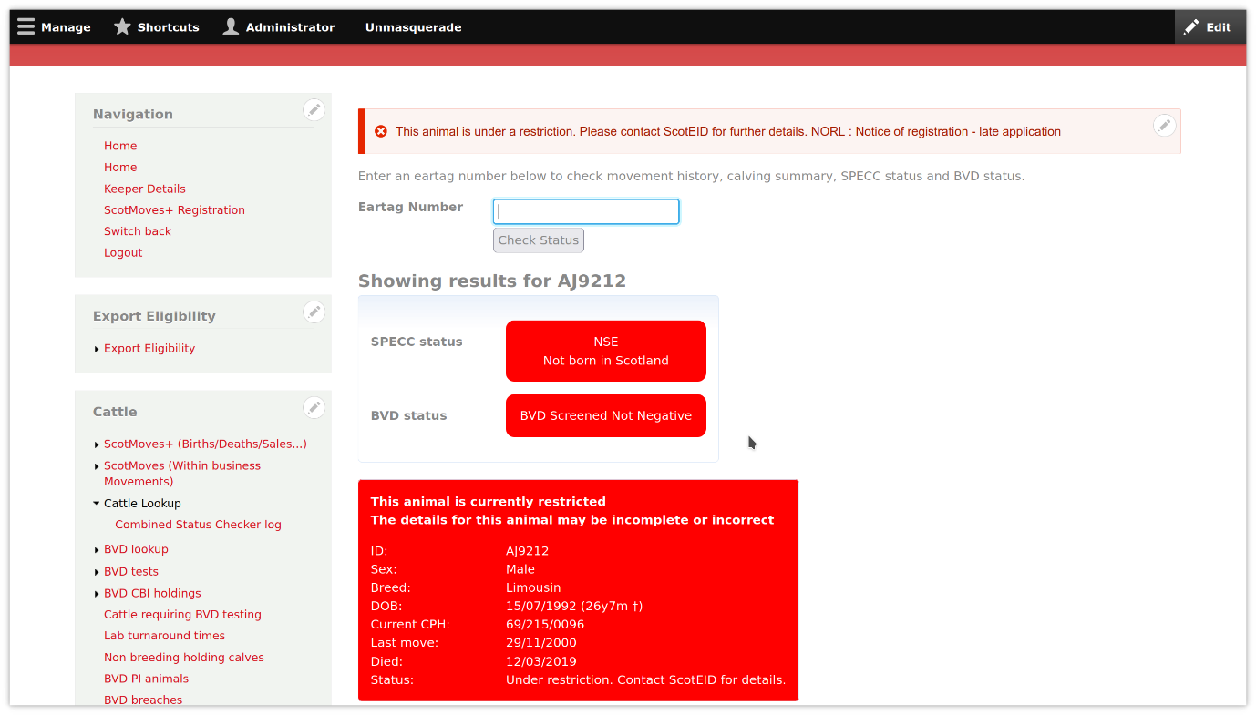

Procedure

OVs will receive regularly, via their VAs, details of those animals pending a passport recall and their current location.

OVs are asked to discuss with FBOs processing cattle the potential risk of accepting animals ineligible for human consumption. The list of animal IDs pending passport recall should be shared with those FBOs interested in putting measures to prevent their slaughter. While FBOs are not required to change their intake procedures nor check ScotEID before accepting an animal for slaughter, it is important they understand the risk in case they are willing to monitor the potential arrival of those animals. When an animal ineligible for human consumption is slaughtered, meat will need to be traced and disposed as an ABP.

OVs are also asked to remain vigilant in relation to animals under restrictions pending passport recall and their last known keeper, with views to prevent their slaughter when possible.

Field Staff are required to:

- Note the contents of the Action Note, plant attending OVs to ensure that the Action Note is read by all FSS staff, and this is noted in the Action/ Information Log.
- Discuss the contents of the Action Note with those FBOs processing cattle in their attending plants.
- Share the list of animals pending passport recall with those FBOs willing to prevent acceptance of animals under restrictions, and to be aware of last known keepers in case they deliver cattle to the abattoir.
- Print a copy of this note for the plant file.

This Action Note will be:

- Uploaded to the Action Note Live Folder and Operations tracker log on SharePoint.
- Forwarded to Website mailbox (websiteteam@fss.scot) for publication on our website.

The Action Note will remain live until either incorporated in the SMOC or revoked.
Copies of the live and revoked Action Notes can be found on SharePoint.

Action Note drafted by | Action Note agreed by | Published | Revoked
Albert Conca | Elena McWatt | Chris Quick
24/09/2024 | 27/09/2024 | 30/09/2024

Action/Information Log
Action Note Number: 2024-09-02
SMOC Chapter: Chapter 2.5 Animal Identification
Implementation Date: 30-09-2024
(Signing the charter below certifies that the Action/Information has been read and understood)
Print Name | Designation | Date | Signature

